**Family Law**

**Workshop 4 – Parenting Orders**

**Anna, Jane, Steven and Paul**

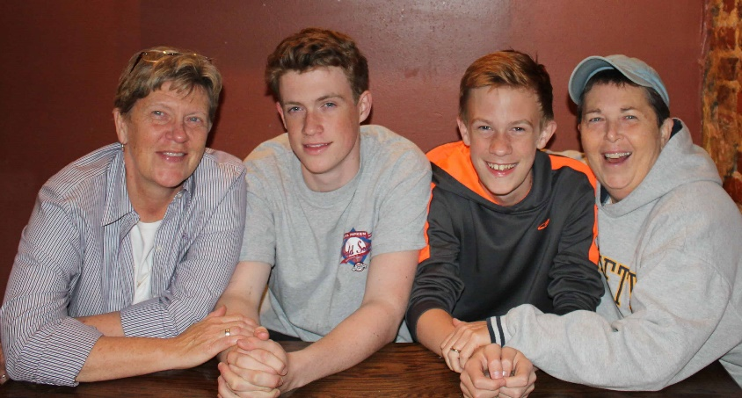

**Hypothetical Scenario**

Jane and Anna had been in a de facto relationship for about 3 years, when they decided to have a child together. They were able to use IVF and donor sperm, and Jane became pregnant. On 5 Jan 2007, Jane gave birth to Steven in Canberra. When Steven was born, Jane took one year off work to care for Steven.

They then decided to have a second child. Anna used IVF and donor sperm and in March 2010, Paul was born. When Paul was born, Anna took a year off work to look after both of them. When Steven was 4 and Paul 1, both started going to child care about 3 days a week, with Anna’s parents looking after them on the other two days.

Both Jane and Anna have been involved with the care and raising of both children, including making decisions to support their health and welfare. Paul and Steven have developed a good relationship with both their mothers and feel equally comfortable in their company. Steven is now a 15 year old active boy and has an outgoing personality. He is very good at school and sport. Paul is now 12, and has autism and dyslexia, which makes school challenging for him. Paul is very reliant on his brother because Steven is sometimes the only one who can calm Paul. Steven cares for his brother very much and looks out for him.

When it comes to parenting, Jane and Anna could not be more different. Jane is a highly structured and driven woman. She has a strong work ethic. She grew up in a relatively strict household, where she was expected to contribute to the chores from a young age. She has always been involved in lots of activities, from chess to swimming. She is of the view that in order to help Steven succeed, he needs to be exposed to lots of opportunities in order to find what he excels at. Since Steven started school, he has done activities after school almost every day. Although they have been instigated by Jane, Steven has generally enjoyed them. Jane believes that a structured home life for Paul will help him develop the life skills he needs and achieve success. Paul also undertakes some activities after school, though not as many as Steven.

Anna on the other hand is a free-wheeling type. She doesn’t follow schedules and despite her best intentions, she is often running late, even to medical appointments. Often, she would prefer to stay at home and play board games. On the weekend, she often has afternoon naps with Steven and Paul on the couch instead of doing homework. Once when Jane went away for a week for work, she returned to find that the kids had not brushed their teeth once. Paul had gone to school without his shoes, and Steven had missed the ACT school tryouts for basketball because he had slept in. Anna said she had forgotten the try-outs, but has no idea how Paul ended up at school wearing one shoe. Although Steven didn’t seem to mind missing the tryouts, Jane was angry that this was an opportunity missed.

This year, Jane began to realise that she has very different parenting values from Anna and that this was what was creating conflict between them. Jane in particular found it difficult not to be exasperated about Anna’s parenting style in front of the kids. Indeed, Jane has caught herself complaining about Anna’s behaviour, and querying her capacity to be a responsible parent. The conflict has become so serious that the two have decided that it would be better to separate.

They now disagree about where the kids should live. Jane wants both kids to live mostly with her, and spend substantial and significant time with Anna. Jane says that the kids, aged 15 and 12 need structure and discipline. Jane also wants sole parental responsibility. She is frustrated trying to make Anna see how important the after school activities are, and doesn’t want to have to consult her all the time.

However, Anna is of the view that the kids should spend equal time with each of them, saying that Jane is too structured. Anna argues that the kids need to rest at home more often, as they are too tired out from school and all the structured activities that they do every week. She would like to have equal shared parental responsibility so that she can have some input into the decisions about what activities they do and put a limit on it if she can see that the kids are doing too much.

Anna is also keen for equal shared parental responsibility because it is almost time for them to decide where Paul goes to high school. Jane believes that the special high school nearby would give Paul more structure. Anna, however, would like to see Paul go to the local high school. Her view is that even if he needs to be in a class with learning support, he will mix with others of his age and with different abilities, and this will give him the social skills he needs to survive in the world. She would like to be consulted about this, and have a conversation to find out what would work best.

Steven and Paul are very close. Steven has helped Paul since they were little. Steven would prefer to live with Anna and spend regular and substantial time with Jane, so that he could relax at Anna’s house. Paul probably prefers to spend time with Jane. Both Jane and Anna agree that the boys should not be separated from each other as the impact on Paul would be too great.